Organizational Structures Assessment Tool (OSAT)
Which structures in your organization are most supportive of relational coordination for each role?
Which structures are least supportive?

- Use your relational map.
- Place the roles from your relational map across the top of the matrix.
- Structures are shown in the left-hand column. Ask “how well each role is supported by each structure?” For example: “Are nurses selected for teamwork with the other groups? Are therapists? Are physicians? Are residents? Are case managers?” Then, “Are nurses trained for teamwork with the other groups?” and so on.
  - STRUCTURE PROVIDES WEAK SUPPORT FOR RC = RED
  - STRUCTURE PROVIDES MODERATE SUPPORT FOR RC = BLUE
  - STRUCTURE PROVIDES STRONG SUPPORT FOR RC = GREEN
- Then debrief:
  - Which structures are currently most/least supportive of relational coordination?
  - Which roles are currently most/least supported by the current structures?
  - Where are the biggest opportunities for improving your structures?
  - What obstacles might you face?

Relational model of change

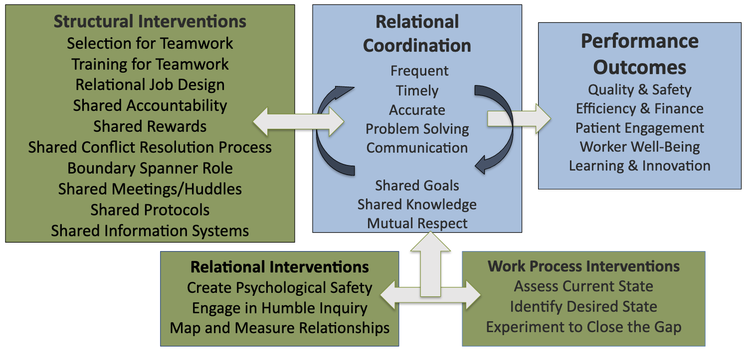
Sample Organizational Structures Assessment Tool (OSAT)

Structures | Nurses | Therapists | Residents | Physicians | Case Managers | Social Workers
Selection for Teamwork
Training for Teamwork
Relational Job Design
Shared Accountability
Shared Rewards
Shared Conflict Resolution
Boundary Spanner Role
Shared Meetings/Huddles
Shared Protocols
Shared Info Systems

THIS STRUCTURE PROVIDES WEAK SUPPORT FOR THIS ROLE | THIS STRUCTURE PROVIDES MODERATE SUPPORT FOR THIS ROLE | THIS STRUCTURE PROVIDES STRONG SUPPORT FOR THIS ROLE

Organizational Structures Assessment Tool (OSAT)

Structures | Role 1 | Role 2 | Role 3 | Role 4 | Role 5 | Role 6
Selection for Teamwork
Training for Teamwork
Relational Job Design
Shared Accountability
Shared Rewards
Shared Conflict Resolution
Boundary Spanner Role
Shared Meetings/ Huddles
Shared Protocols
Shared Info Systems

THIS STRUCTURE PROVIDES WEAK SUPPORT FOR THIS ROLE | THIS STRUCTURE PROVIDES MODERATE SUPPORT FOR THIS ROLE | THIS STRUCTURE PROVIDES STRONG SUPPORT FOR THIS ROLE

