## 

## **Organizational Structures Assessment Tool - Guidelines**

After creating a Relational Map with your team, please complete an Organizational Structure Assessment using the template below, inserting the workgroups from your relational map and adding more columns as needed. See Part II of *High Performance Healthcare* for insights into each organizational structure.

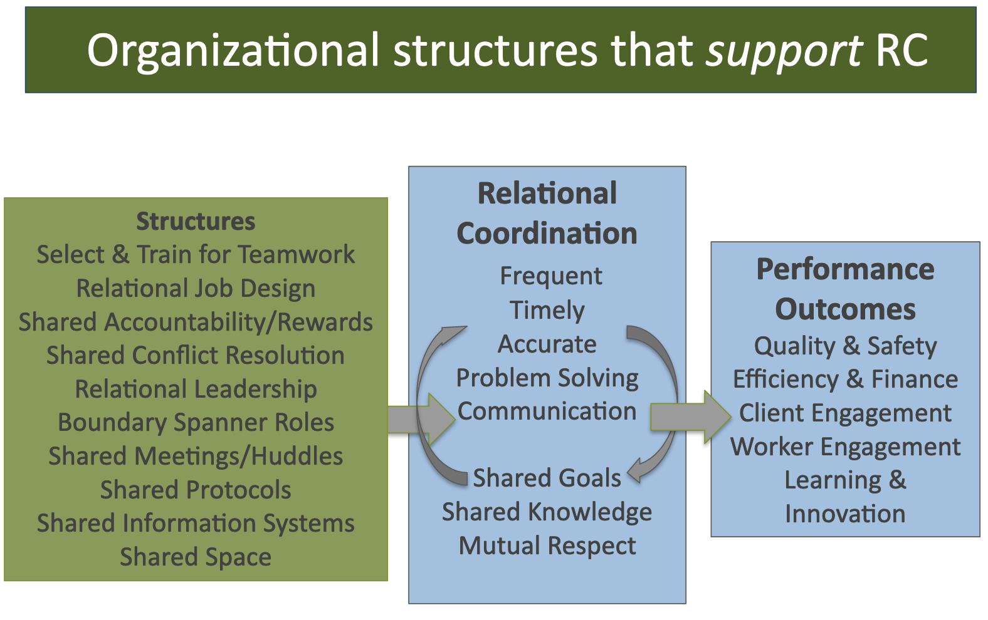

Sample Organizational Structures Assessment Tool (OSAT)

|  |  |  |  |  |  |  |
| --- | --- | --- | --- | --- | --- | --- |
| **Structures** | Nurses | Therapists | Residents | Physicians | Case Managers | Social Workers |
| **Selection for Teamwork** |  |  |  |  |  |  |
| **Training for Teamwork** |  |  |  |  |  |  |
| **Relational Job Design** |  |  |  |  |  |  |
| **Shared Accountability** |  |  |  |  |  |  |
| **Shared Rewards** |  |  |  |  |  |  |
| **Shared Conflict Resolution** |  |  |  |  |  |  |
| **Boundary Spanner Role** |  |  |  |  |  |  |
| **Shared Meetings/Huddles** |  |  |  |  |  |  |
| **Shared Protocols** |  |  |  |  |  |  |
| **Shared Info Systems** |  |  |  |  |  |  |

|  |  |  |
| --- | --- | --- |
| **THIS STRUCTURE PROVIDES WEAK SUPPORT FOR THIS ROLE** | **THIS STRUCTURE PROVIDES MODERATE SUPPORT FOR THIS ROLE** | **THIS STRUCTURE PROVIDES STRONG SUPPORT FOR THIS ROLE** |
|  |  |  |

Organizational Structures Assessment Tool (OSAT)

|  |  |  |  |  |  |  |
| --- | --- | --- | --- | --- | --- | --- |
| **Structures** | Role 1 | Role 2 | Role 3 | Role 4 | Role 5 | Role 6 |
| **Selection for Teamwork** |  |  |  |  |  |  |
| **Training for Teamwork** |  |  |  |  |  |  |
| **Relational Job Design** |  |  |  |  |  |  |
| **Shared Accountability** |  |  |  |  |  |  |
| **Shared Rewards** |  |  |  |  |  |  |
| **Shared Conflict Resolution** |  |  |  |  |  |  |
| **Boundary Spanner Role** |  |  |  |  |  |  |
| **Shared Meetings/ Huddles** |  |  |  |  |  |  |
| **Shared Protocols** |  |  |  |  |  |  |
| **Shared Info Systems** |  |  |  |  |  |  |

|  |  |  |
| --- | --- | --- |
| **THIS STRUCTURE PROVIDES WEAK SUPPORT FOR THIS ROLE** | **THIS STRUCTURE PROVIDES MODERATE SUPPORT FOR THIS ROLE** | **THIS STRUCTURE PROVIDES STRONG SUPPORT FOR THIS ROLE** |
|  |  |  |

With your team:

* Place the roles from your relational map across the top of the matrix.
* Structures are shown in the left-hand column. Ask “how well each role is supported by each structure?”
  + STRUCTURE PROVIDES WEAK SUPPORT FOR RC = RED
  + STRUCTURE PROVIDES MODERATE SUPPORT FOR RC = BLUE
  + STRUCTURE PROVIDES STRONG SUPPORT FOR RC = GREEN

Ask the following questions:

* Are people in this role **selected** for their ability to engage in teamwork with other roles in this work process?
* Are people in this role **trained** to engage in teamwork with other roles in this work process?
* Do people in this role have a **job design** that includes coordination responsibilities with other roles in this work process?
* Do people in this role have **shared accountability** for patient outcomes, together with other roles in this work process, or are they only accountable for their own tasks and outcomes?
* Do people in this role have **shared rewards** (monetary or recognition) for patient outcomes, together with other roles in this work process?
* Do people in this role have access to a **shared conflict resolution** process when there are conflicts with other roles?
* Do people in this role have **leaders who work to build relationships** between them and the other roles involved in this work process?
* Do people in this role have a **boundary spanner** (case manager for example) between themselves and other roles, to help coordinate their work?
* Do people in this role have **shared meetings or huddles** with other roles, to help coordinate their work?
* Do people in this role have **shared protocols** (care pathways, checklists, etc.) with other roles, to help coordinate their work?
* Do people in this role have **shared information systems** with other roles, to help coordinate their work?
* Do people in this role have **shared space** (physical, virtual) with other roles, to help coordinate their work?

2) When the matrix is complete, ask: Where do you see the biggest potential for your organization to invest in these structures?